
Koneru Lakshmaiah Education Foundation
(Deemed to be University estd. u/s. 3 of the UGC Act, 1956)
Off-Campus: Bachupally-Gandimaisamma Road, Bowrampet, Hyderabad, Telangana - 500 043. Phone No: 7815926816, www.klh.edu.in

STUDENT CASE STUDY EXECUTION REPORT
Department | FED
Subject | DSA-2
Academic Year | 1-111 Semester | 2025-26
Faculty Name | Mohd. Razia Alangir Banu
Student Name | P. Yaswanth Surya
Roll Number | 2520030581
Branch | CSE
Course Outcome | CO 3
Case Study Topic: Smart Healthcare Connectivity using Minimum Spanning Tree (MST)
Work Done Summary:
In this case study, we implemented Minimum Spanning Tree (MST) algorithms to connect hospitals with minimum communication cost.
Hospitals were represented as vertices and communication links between hospitals were represented as weighted edges. Kruskal’s and Prim’s algorithms were used to find the minimum-cost network that connects all hospitals without forming cycles.
We also compared the performance of both MST algorithms and analyzed the total communication cost.

Implementation Details:
1 Modeled hospitals and communication links as a weighted graph.
2 Implemented Kruskal’s Algorithm using Union-Find.
3 Implemented Prim’s Algorithm using Priority Queue.
4 Generated Minimum Spanning Tree for hospital connectivity.
5 Calculated total communication cost.
6 Compared MST results obtained using both algorithms.
• Compared MST results obtained using both algorithms.• Compared total network costs obtained from both MST algorithms. 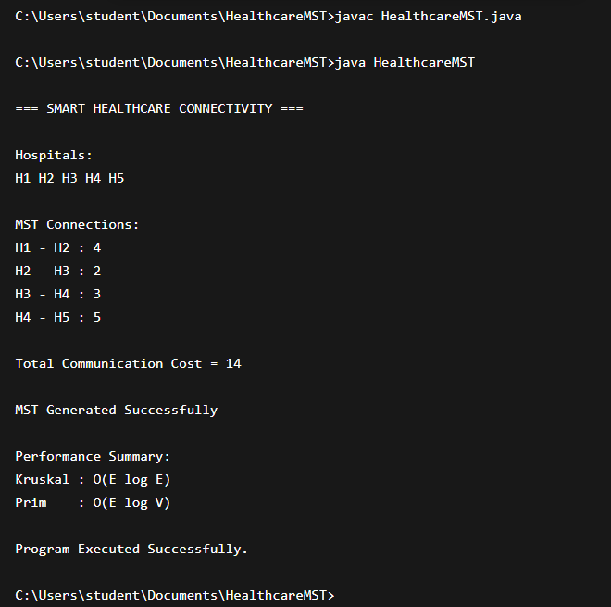

Result: Screenshots / Output
The MST algorithms successfully connected all hospitals with minimum communication cost.

Sample Output:

Hospitals: H1, H2, H3, H4, H5
Selected Connections:
H1 - H2 (4)
H2 - H3 (2)
H3 - H4 (3)
H4 - H5 (5)

Total Communication Cost = 14
Minimum Spanning Tree Generated Successfully

Time Complexity:

• Kruskal's Algorithm: O(E log E)
• Prim's Algorithm: O(E log V)

The MST reduced overall communication cost while maintaining full connectivity among hospitals.
.

GitHub Link: https://github.com/yaswanthsurya-99/DSA-2
Student Signature Faculty Signature

